Elevate

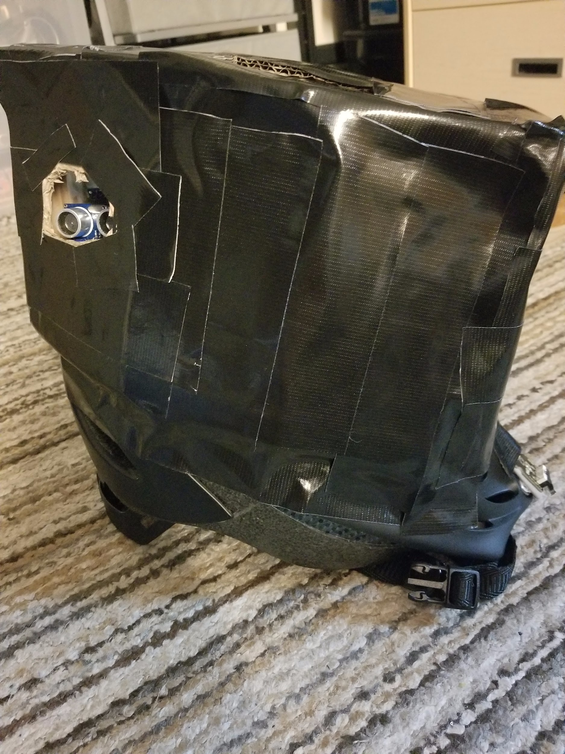

User Guide

Version 1.0

Matthew Horger, Kevin Tayah, Jake Rauch

Table of Contents

Getting Started ………………………………………………………………………………3

Using your helmet

Wearing …………………………………………………………………………… 5

Charging …………………………………………………………………………… 6

Accessing Data …………………………………………………………………… 7

Troubleshooting ………………………………………………………………… 8

Using the Mobile Application

Using current location ………………………………………………………… 10

Finding routes …………………………………………………………………… 11

Troubleshooting ………………………………………………………………… 12

Using the Database

Creating your user account …………………………………………………… 14

Logging into your account …………………………………………………… 15

Accessing hill data ……………………………………………………………… 16

Linking products ………………………………………………………………… 17

Troubleshooting ………………………………………………………………… 18

Contact Information …………………………………………………………………… 19

**Getting Started**

To get started with your new Elevate system, please unpack the helmet carefully from the box and set it aside. You will find included in your packaging a plastic pouch containing this user manual, your login information for web services, warranty information, a rechargeable battery module, and a USB type B cable. Please keep your warranty information safe and secure in the event that you need to file a claim with your helmet.

To start, inspect the helmet and especially the straps. Make note of any frays or tears that may have occurred during packing. If any damage has occurred to the straps or to any other part of the helmet upon opening the package, please take your warranty information and contact the email location on the first page of the packet.

If no visible damage has occurred, take the batteries located inside the power compartment of the helmet out of the encasement and place them inside the rechargeable battery module.

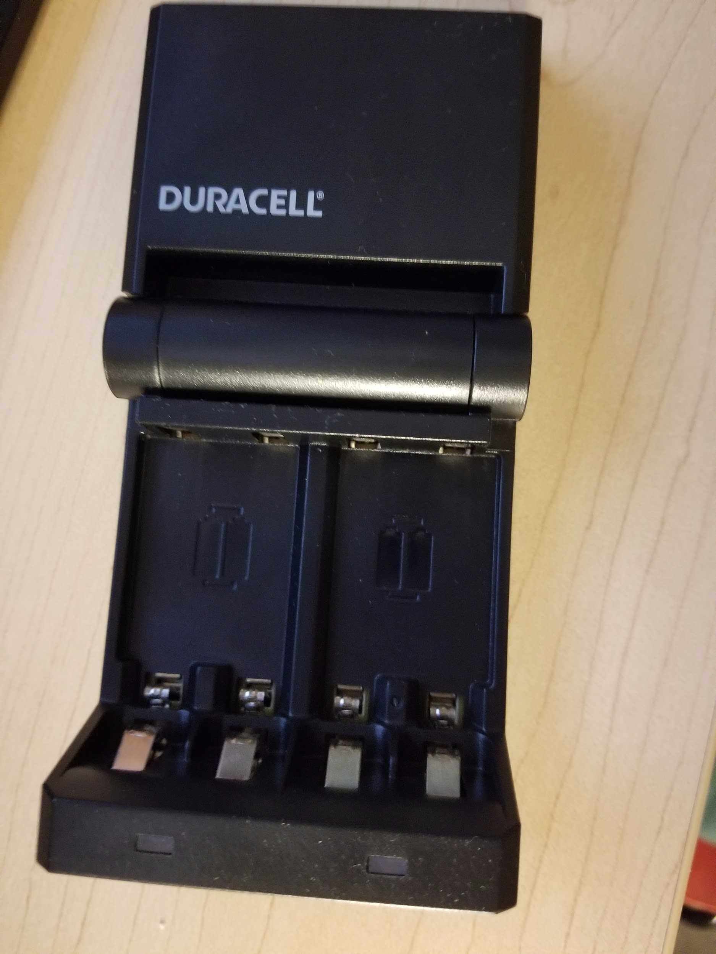

Plug in the module into a suitable wall outlet that has surge protection. Once the module light has turned green, you must place the batteries back into the helmet and press the power switch on, located next to the battery compartment you. You will now hear two beeps signaling the successful powering of the helmet. The helmet will now be able to detect objects in your blind spots and alert you.

**Using your Helmet**

**Wearing**

To put on your helmet, first place the helmet over your head and mimic connecting the two straps together under your chin. In the event that the straps are too loose or are too tight, please adjust the straps accordingly using the controller found on one of the straps. The helmet should be tightly secured, yet comfortably resting on your head.

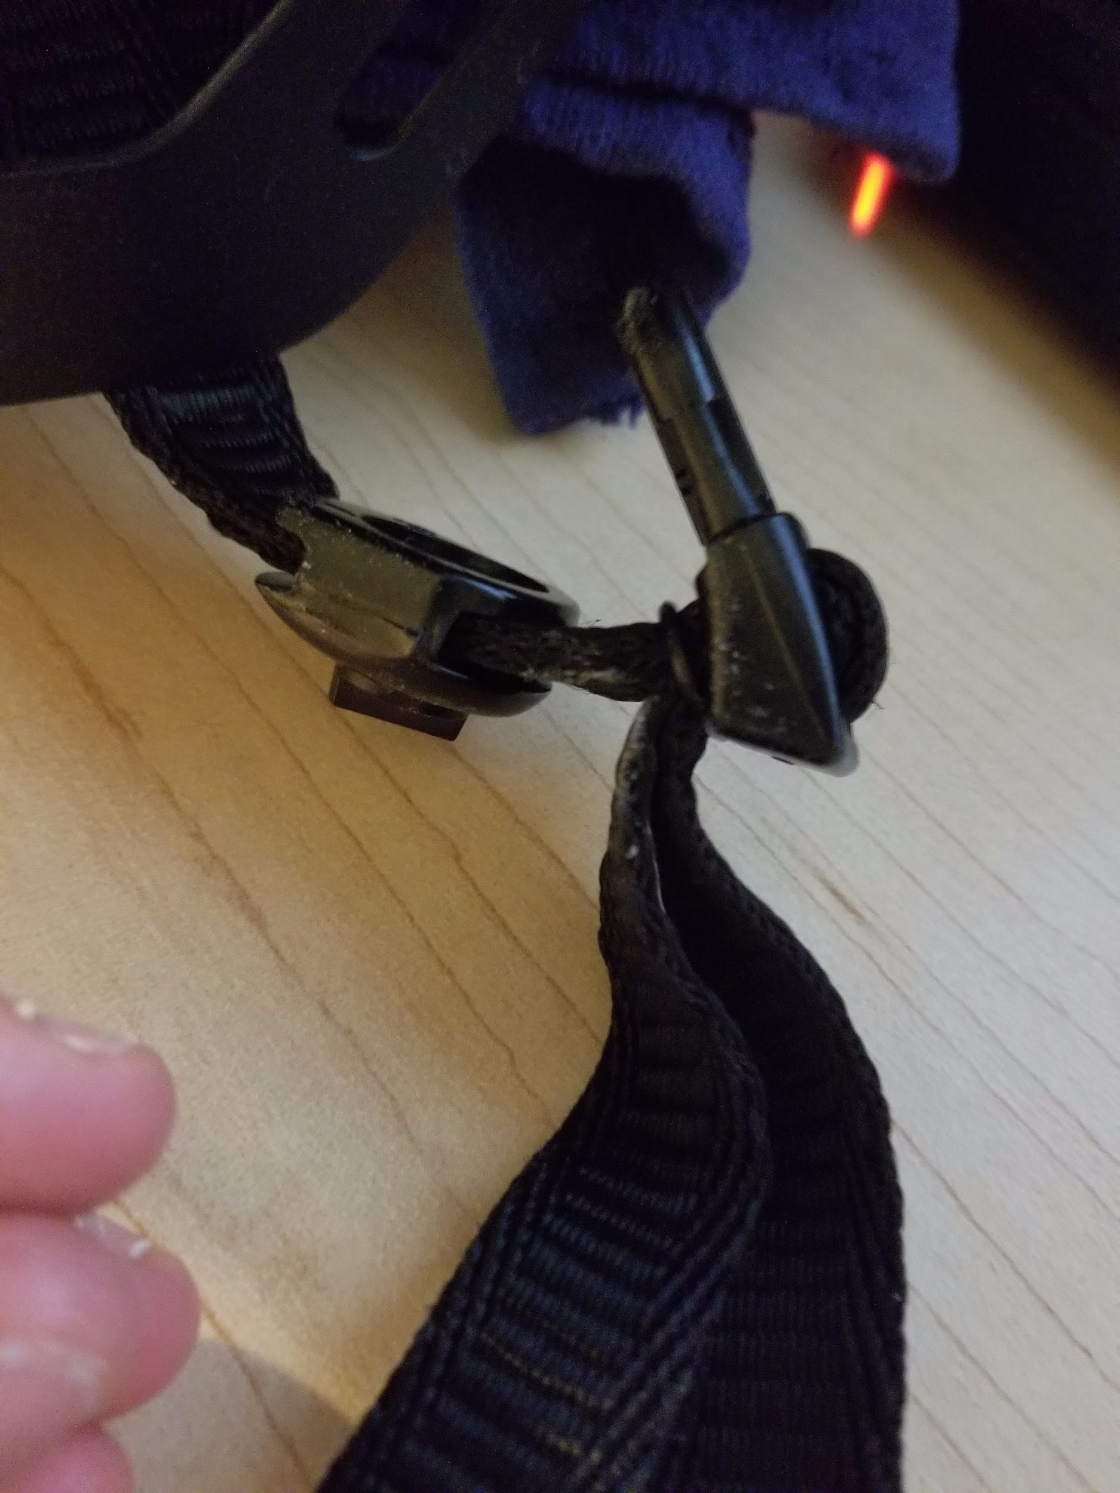

Once the proper strap length has been acquired, snap the two straps together while wearing the helmet. Shake your head around from side to side as if you are shaking your head ‘no’ multiple times. If you feel the helmet is still loose or moving too much, remove the helmet from your head and locate the adjustment knob on the back on the helmet.

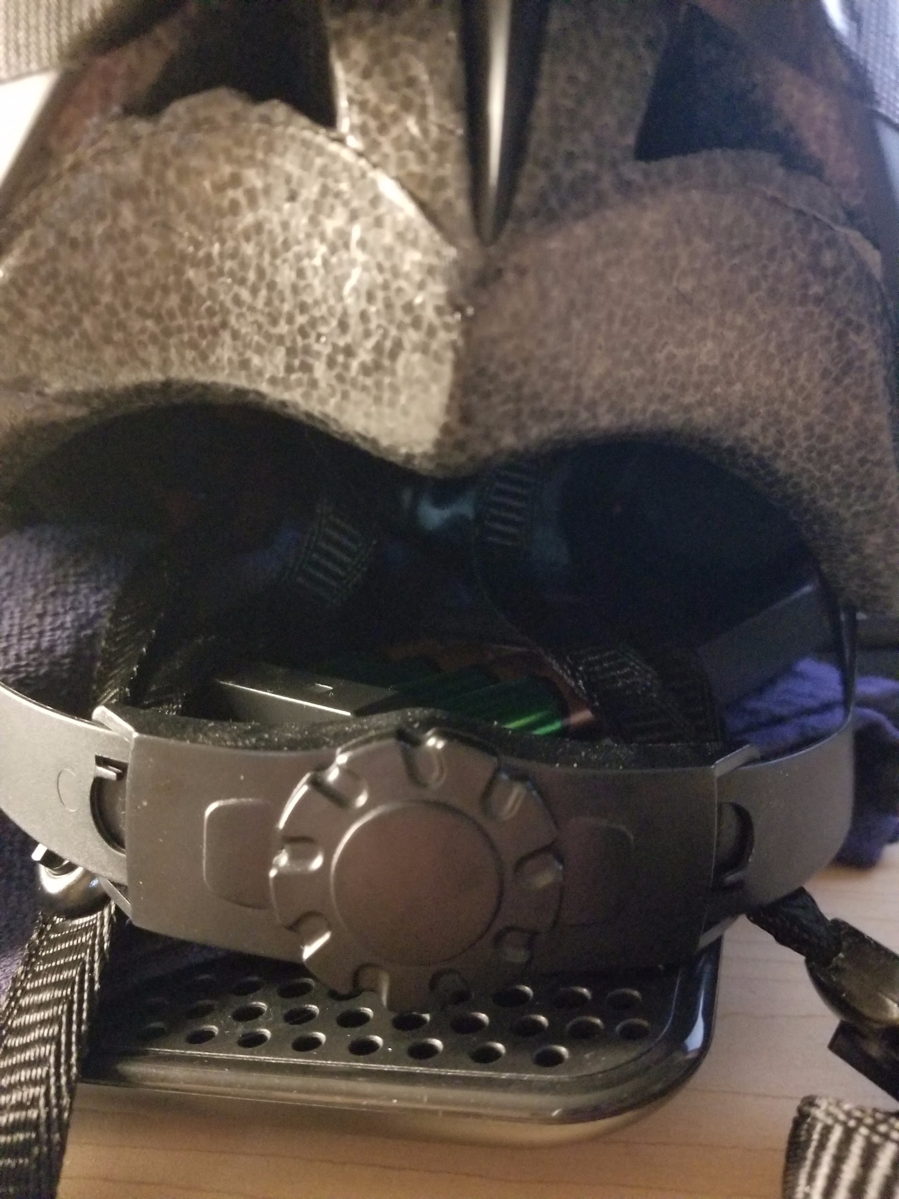

Turn it clockwise until it is tighten. Place the helmet on your head, secure the straps, and repeat shaking your head from side to side to test if the helmet is still too loose. This process may take some trial and error to find the proper tightness setting that feels comfortable for you.

**Charging**

After properly wearing your helmet for a significant period of time, the batteries will drain after about 9 hours of normal usage. We recommend that you charge your helmet daily after usage so that your helmet is able to properly function over the batteries’ lifetime.

You may remove the batteries from the power compartment of the helmet and place them in the supplied rechargeable module. It will normally take 12 hours to fully charge a set of depleted batteries, but times may vary for you depending on how depleted the batteries are and what kind of wall outlet you are using.

You may also use disposable, non rechargeable batteries for your helmet, however, we recommend that you stick with the supplied rechargeable ones. Helmet functionality and battery lifetime was testing and documented with the usage of the rechargeable ones. The use of non rechargeable batteries may or may not work properly with the helmet or last as long as the supplied batteries. Use at your own risk.

**Accessing Data**

If you are interested in viewing the data and analytics stored within the helmet, please visit https://www.arduino.cc/download_handler.php on your desktop or laptop to download the Arduino software that will allow you to interact with the helmet.

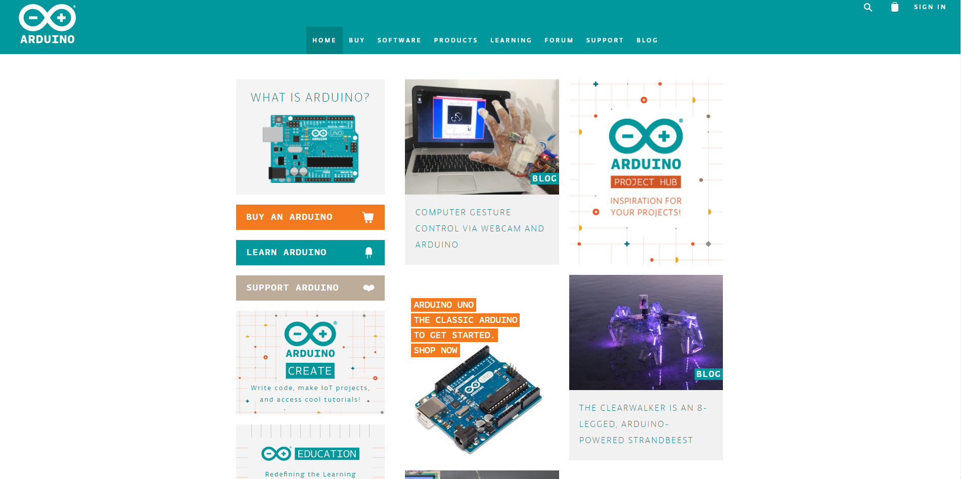

Upon completion of the installation, take the supplied USB B cable and hook it up to the main Arduino on the helmet. Take the USB end and plug it into the computer you recently installed the Arduino software on. After the appropriate drivers for the helmet install the first time you plug the helmet into your computer, select the tools drop-down menu under the Arduino software. Hover your mouse cursor over the port selection. If done correctly, you should be able to see your helmet connected to the software. If your helmet is not showing up, please restart the Arduino software by closing it and re-opening it.

Once you select the port in which your Arduino is connected, go back into the tools drop down menu and click on serial monitor. You will now be able to see all the data about your helmet.

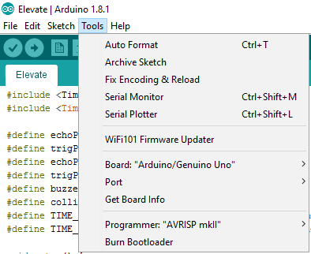

**Troubleshooting**

In the event that your helmet does not properly detect objects in the range of the motion sensors, or does not properly alert you in the event of collision or an object comes in range of the sensors, or if you have any other issues with your helmet, please follow these steps:

* Take the batteries out of the helmet, wait 10 seconds, and put them back in.
* If no data is being displayed on your computer, try following the same steps with a new computer, especially one running Windows 10.
* If you think any structural or water damage has occurred, please contact us so we can properly process your warranty.

**Using the Mobile Application**

**Using Current Location**

Upon going to our website, you can access certain hill data to see what route is the best suited for your needs. When you first load in the website, a pop-up will ask you to use your current location. Please click accept. If you click block, our website will not properly work and you will have to contact our support team to fix your browser.

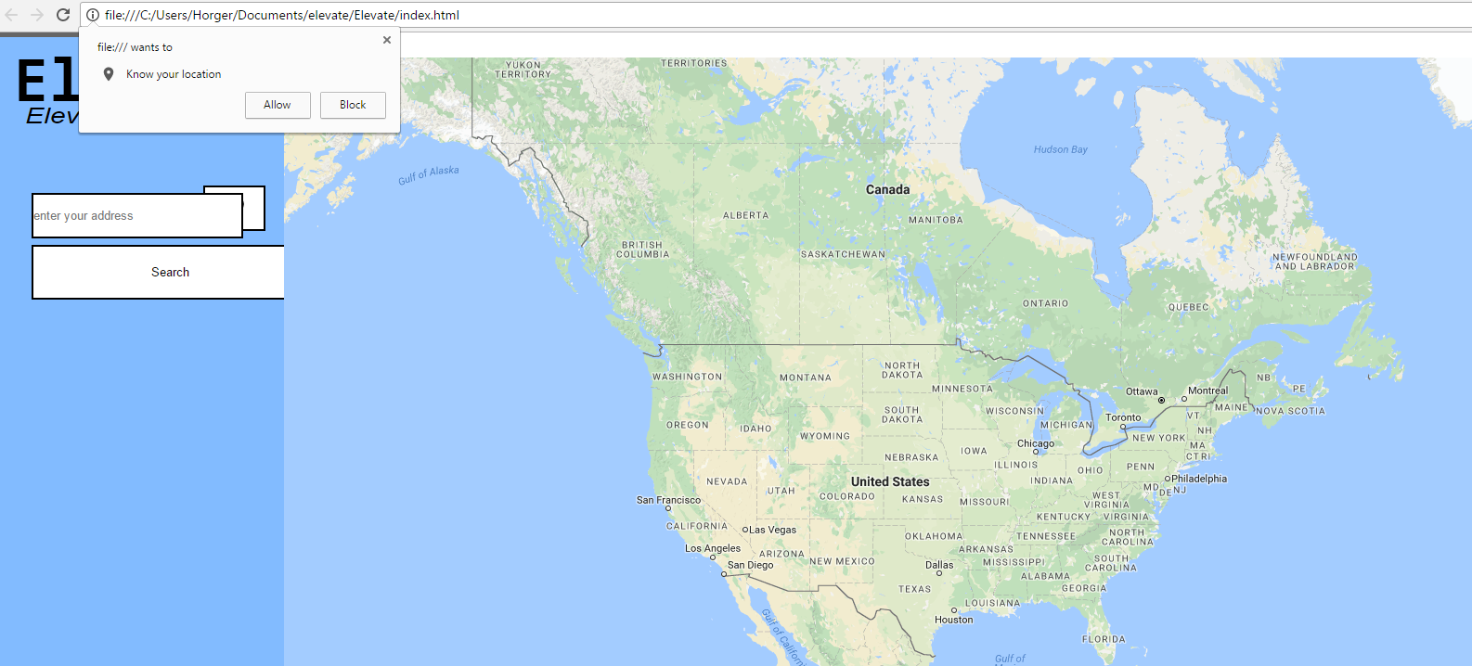

**Finding Routes**

Once you grant our website access to your location, zoom into the map by double clicking the area you want to zoom into. You will notice elevation data surrounding the route. If you do not grant your location, you can use the search location bar located in the website. Please type a full address including street, city, zipcode, and state for best results.

**Troubleshooting**

In the event that your browser or mobile phone does not support our website, please try using a different browser or restarting your phone. Please make sure that Javascript is enabled on your browser by allowing any popups or accepting any requests for locations.

**Using the Database**

**Creating your user account**

To create your online user account to track your helmet usage and see where you have been, take the login information card provided in the plastic pouch and call 1-800-ELEVATE to activate your account. You will not be able to login unless you validate your account information. Upon calling the activation hotline, you will be prompted to enter a descriptive name for the helmet and provide your login information. Your account will then be activated upon completion of the phone call.

**Logging into your account**

Upon activating your account by calling the hotline on page 14 or on your login information card, go to 192.168.9.10/gpstrack on your desktop. You will be prompted with a notification that will ask you to enter your credentials. Depending on what browser you are using, this could be a drop-down notification or a window that displays on your screen.

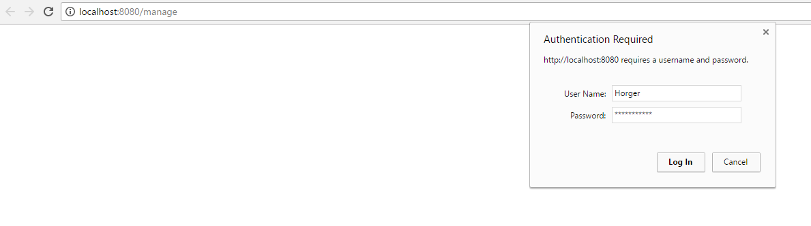

You will enter your login information and make sure that you do not check the box to save your login information. This could cause a security issue to the system, so you should save your login information card and protect it carefully.

**Accessing hill data**

Upon successfully logging into the system, you will be prompted with a screen that contains a map centered on your last known location that was synchronized with the helmet. You will be able to see waypoints of the locations you visited as well.

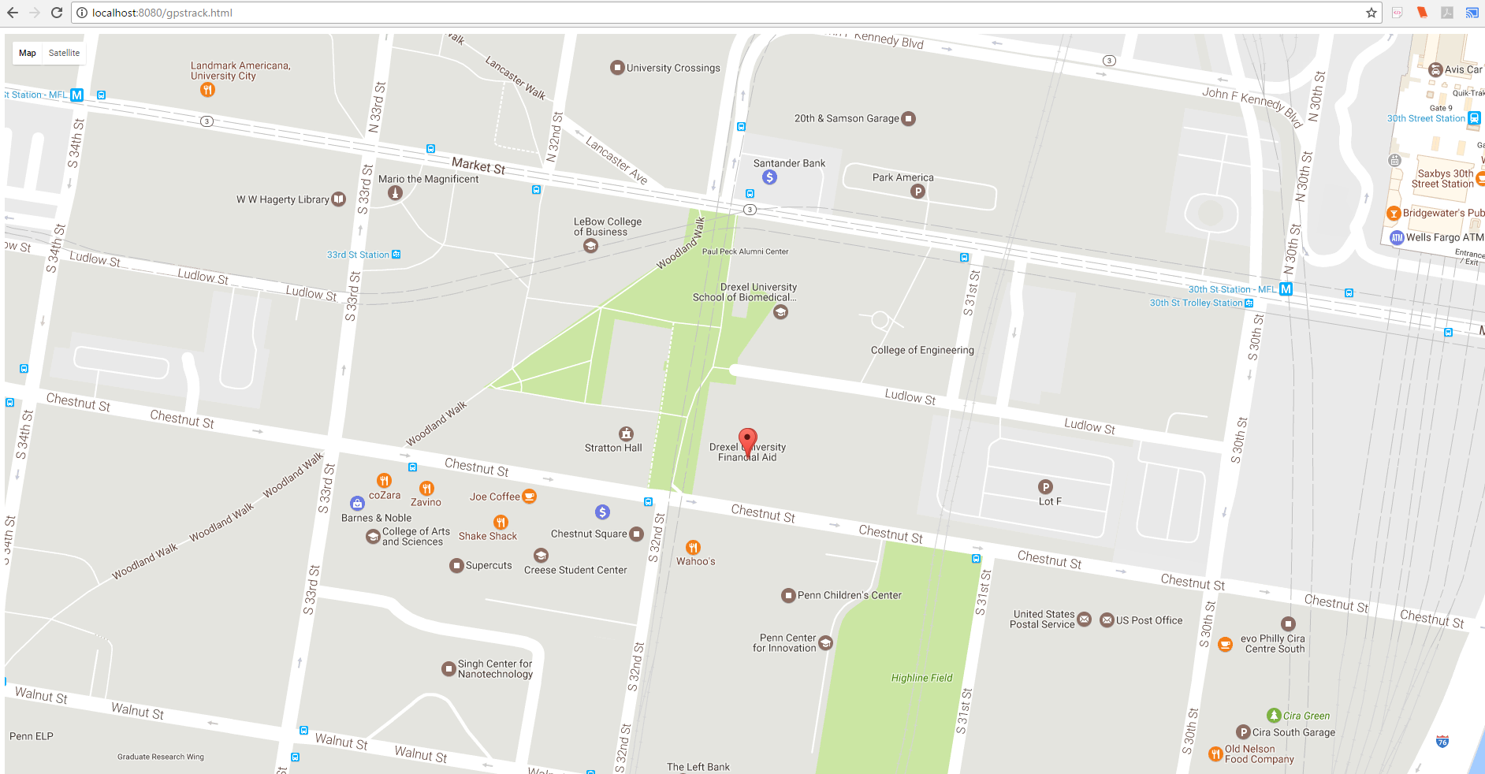

To access elevation data for any of those waypoints or any point on the map, simply click on said point. A pop-up window will appear giving you the coordinates and elevation data for that specific point. You can also move the map around by clicking and dragging your mouse pointer around your screen. By doing so, you can view noticeable elevation changes based on the style of the map.

**Linking product**

If you purchase another Elevate helmet and want to synchronize two helmets under one account, please follow the same steps to activate the account. Upon activation of the second account, please email our support team with both your account information and an account which you want both helmets registered under. Our support staff will be in touch with you to provide further information past this manual.

**Troubleshooting**

In the event that you can not login to our system or view any of your waypoints on the map, please follow these steps:

* Make sure your login information is correct
* Logout of our system
* Restart your computer
* Contact our support team

**Contact Information**

**Activation Hotline - 1800-ELEVATE (1-800-353-8283)**

**Support Team - support@elevate.org**

**Warranty Information - warranty@elevate.org**

**Business Inquiries - contact@elevate.org**